

Samsung B100

Description
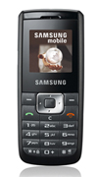
SAMSUNG Impact is a compact mobile that meets your communication and entertainment needs. A true audio entertainer,this slider plays music files (easily stored on microSD) and tunes into FM radio.

STORE PRICE: Rs 3,288 /-
ONLINE PRICE: Rs 3,105 /-

Brand : Samsung
Model Name : B520
Released Year : 2008
Phone Memory : 20 MB internal memory
External Memory : microSD(TransFlash)
Colors : Black
Form : Slide
Dimensions : 96 x 47 x 17.5mm
Weight : 94 g

